Lab report 08:

Student Name: Nguyen Truong Giang

StudentId : 20194751

Ex1:

1. To see which partition of home directory, we can use command “df -h” and see which partition of of root directory like:

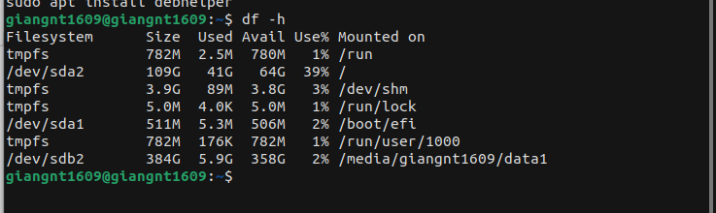In the photo, the root directory is in */dev/sda2 so* the home directory in partition */dev/sda2*

2.

There are many ways to see all the partition in your system. We can you “lsblk” command to see the short partition tree or use “sudo fdisk -l” to see more information like physicall addresses, sizes,...

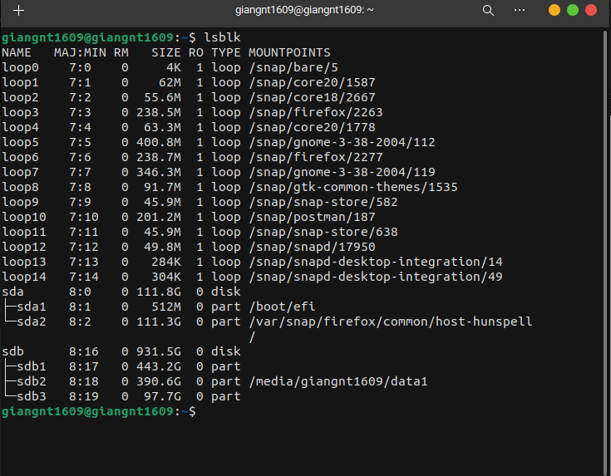

Or using “sudo fdisk -l”

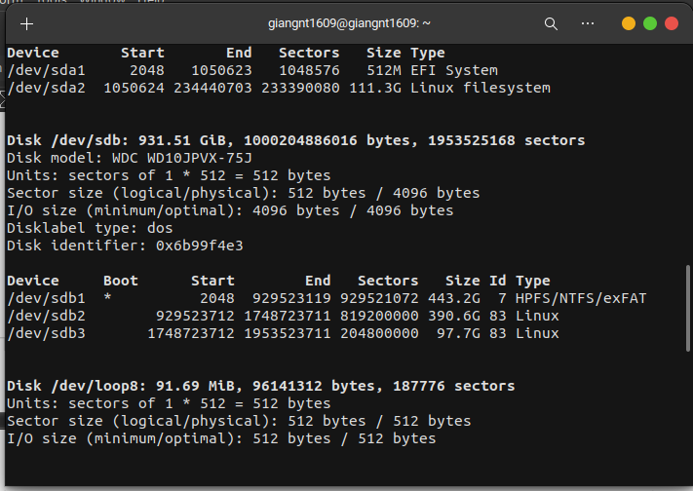

3.

To see the total size of UbuntuOS, we can use command “du -sh / “ to see the total size and wait the result.

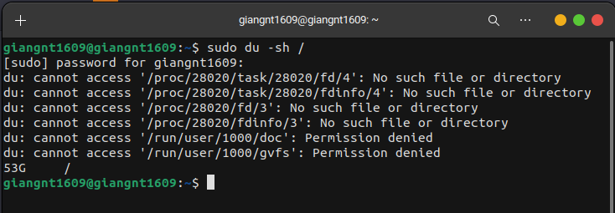

In my system, the total size is about 53Gb.

Ex2:

1,2

use disk to create a new patition 3 (test)

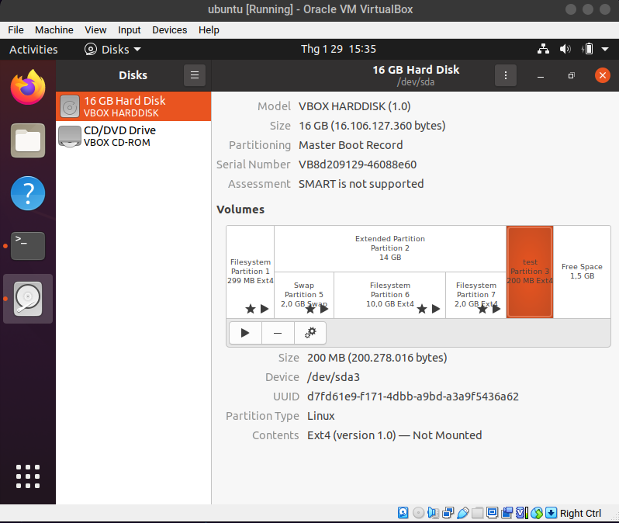

3. F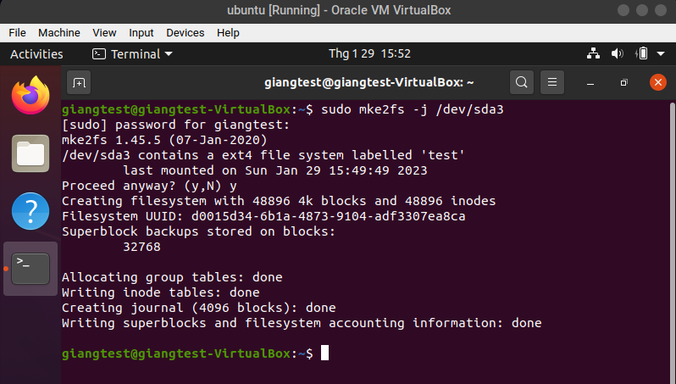ormat with ext3:

4.

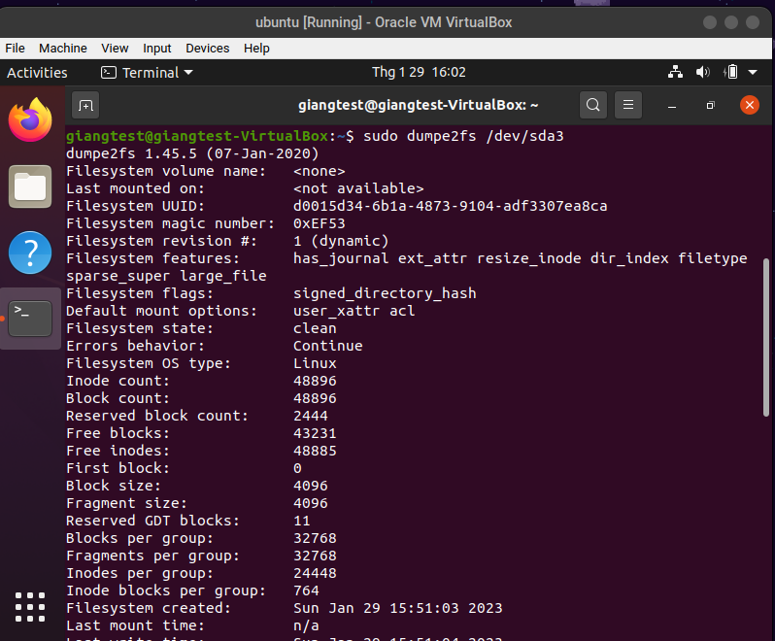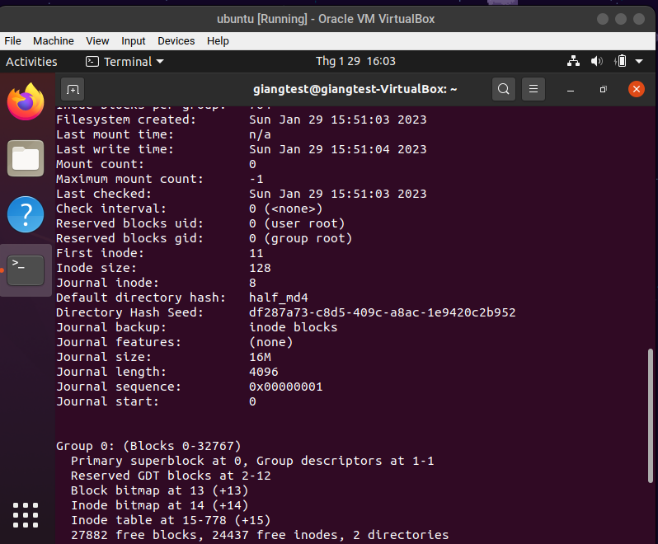

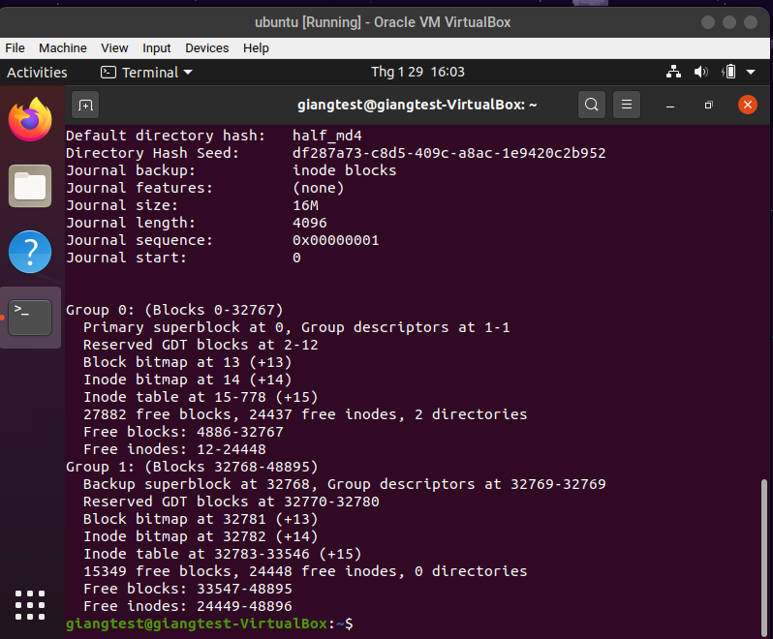

5.

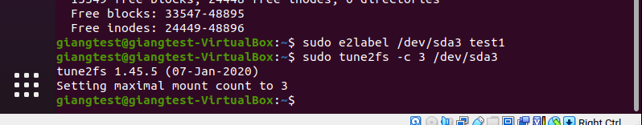

6.

The Filesystem volume name and maximum mount count was changed.

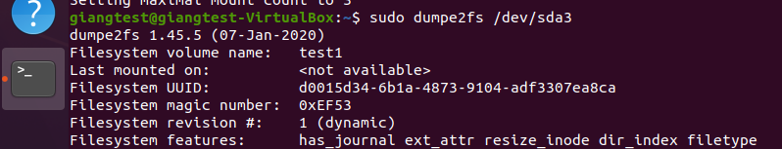

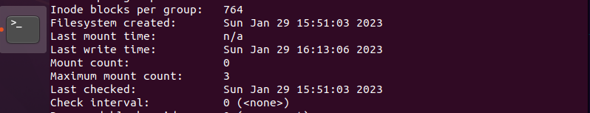

Ex3 :

1.

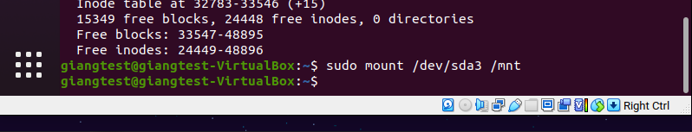

2.

In this directory, just having a directory “lost+found”

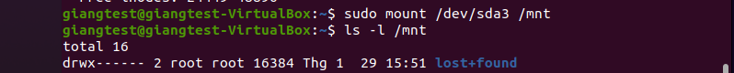

3.

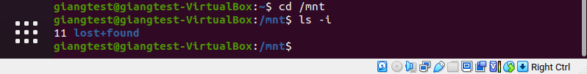

The inode of “lost+found” is 11

The inode of /mnt is 2 and it’s directory.

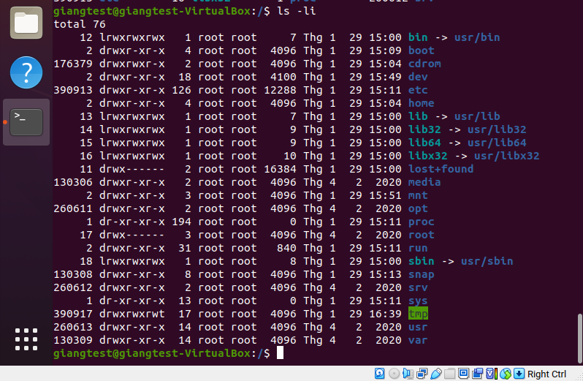

4.

+ Create a mount point directory for the new partition *mnt/homedirs*



*+*Mount the partition /*dev*/sda3 to the mount point directory:



*+* Copy the contents of the existing home directories to /*dev/sda3*



*+*Change the ownership of the copied home directories



5.

6.



7.

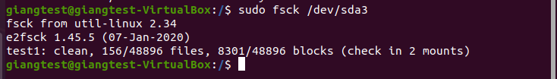

Ex4:

1.

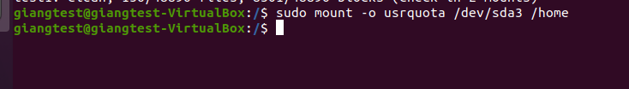

If you want a file system to be automatically mounted at boot time, you need to add an entry for it in the /etc/fstab file. The entry should specify the device name or the UUID of the file system, the mount point directory, the file system type, mount options and dump and pass options.

2.

